**Problem Statement**

1. On dashboard list of menus shows and every menu having the “unread notice” count as shown below.

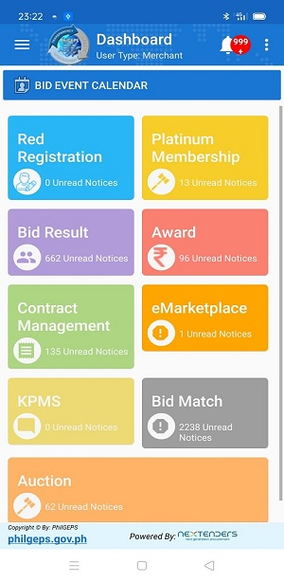

1. Click on main menu another sub-menu or listing will open as shown below.

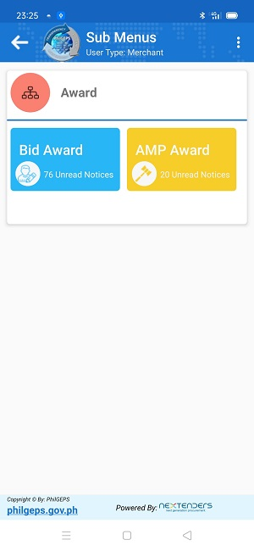

Sub menu also having the total number of “unread notice” count.

Once click on the sub-menu below screen open in which we are showing the listing of all notices for that menu. This list content the both read & unread notice count.

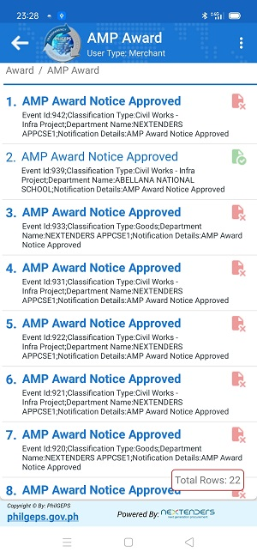

If user click on any unread notice then selected notice should change as read (Remove the bold style) and icon also need to change.

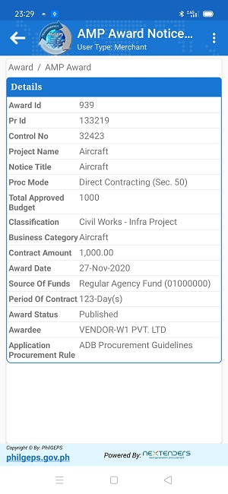This happens once details page load successfully on clicking the list view.

**Issue:** Whenuser navigate to detail page then below action need to happens.

1. For selected list item need to change as normal font (Remove bold style)
2. For selected sub menu decrease the count by 1.
3. For selected main menu decrease the count by 1.

**Reference:** In android this handled by using the preferences.